We Are Eco Heroes
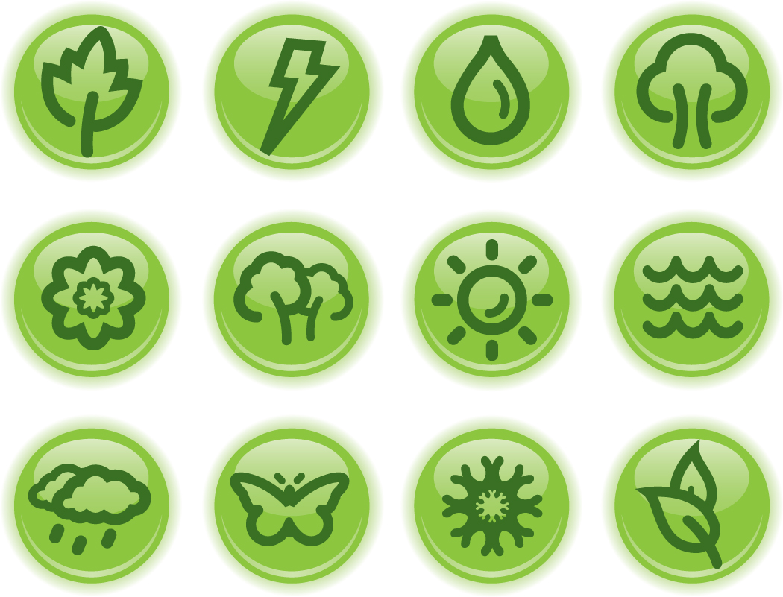
We take good care of all living things,
All living things, all living things,
We take good care of all living things,
‘Cause we are Eco Heroes!

CHORUS

This is the way we save the Earth,
Save the Earth, save the Earth,
This is the way we save the Earth,
‘Cause we are Eco Heroes!
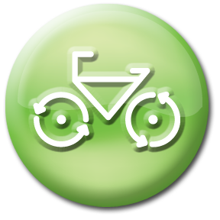
We keep the air clean by riding our bikes,
Riding our bikes, riding our bikes,
We keep the air clean by riding our bikes,
‘Cause we are Eco Heroes!

CHORUS
We take a shower instead of a bath,
Instead of a bath, instead of a bath,
We take a shower instead of a bath,
‘Cause we are Eco Heroes!

CHORUS

We put our litter in the bin,
In the bin, in the bin,
We put our litter in the bin,
‘Cause we are Eco Heroes!

CHORUS
We look after the things in our playground,
Our playground, our playground,
We look after the things in our playground,
'Cause we are Eco Heroes!

CHORUS
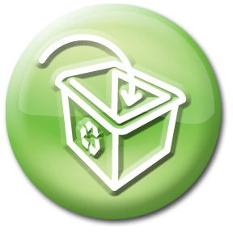
We always remember to recycle,
Recycle, recycle,
We always remember to recycle,
'Cause we are Eco Heroes!

CHORUS
We like to be happy and healthy,
Healthy, healthy,
We like to be happy and healthy,
'Cause we are Eco Heroes!

CHORUS

We turn off everything at the wall,
At the wall, at the wall,
We turn off everything at the wall,
‘Cause we are Eco Heroes!

CHORUS
We like to grow and eat local food,
Local food, local food,
We like to grow and eat local food,
'Cause we are Eco Heroes!

CHORUS

We’re responsible for helping our World,
Helping our World, helping our World,
We’re responsible for helping our World,
‘Cause we are Eco Heroes!

This is the way we save the Earth,
Save the Earth, save the Earth,
This is the way we save the Earth,
‘Cause we are Eco Heroes!
Updated October 2011

