

January 2011

Happy New Year to you all! We hope you had a wonderful Christmas holiday and enjoyed as restful a time as possible!


Improvements
Just before the holidays we were delighted that the
back gym hall cloakroom doors were replaced. There is
however still some work to be done to completely finish but
the fact that they have been renewed is incredible as the
previous ones had certainly seen the end of their shelf life!

Sincere thanks
We would like to say a sincere thank-you for supporting us with our recent fundraising activities and raising a magnificent amount of money.
- since we began our own ‘Rag Bag’ re-cycle collection point for clothes about 9 months ago the goods have been transferred into cash. This has raised £69.20. Amazing!
- our ‘Dress as You Please Day’ for Hallowe’en made £269.03. Thank-you!
- the Christmas Concert, tickets and raffle, totalled a superb £805.70.
The money accrued from these three fundraisers will go towards paying for all the transport costs for the year for trips and competitions.
The £407.70 made from the selling of the Christmas cards will allow us to start replacing and up-grading our reading material for the Upper Block.
As you can see you have supported us tremendously during this school year and we can only extend our grateful thanks to each and everyone of you.

Attendance / Lateness – IMPORTANT!
Staff in school are concerned about the number of pupils who are arriving at school after the bell. This can run from anything from a few minutes to an hour! Please remember that if your child has a busy road to cross the Lollipops finish at 9.10am! If a pupil is continually late for school a member of the Senior Management Team will now contact the appropriate parent, either by phone call or letter, to discuss their concerns.
Angus Council procedures state that -
‘Parents are responsible for ensuring that their children attend school regularly and arrive on time. … Regular and punctual attendance is linked closely to achievement and school staff wish to work with parents to ensure that children can reach their full potential. The school is required by law to maintain an accurate record of the attendance and absence of each pupil and parents are requested to assist in this process by keeping the school informed if their child is to be absent for any reason’.
Please continue to support us by contacting school to inform us when your child is not
well and the reason for their non- attendance i.e. contacting school between 8.30am &9.45am.
However the ‘Pupil Absence Procedures’ also state that –
- ‘if there has been no contact from the parent, then the emergency contact will be tried. If this also proves to be unsuccessful then a senior member from school will liaise with the cluster School and Family Support Service Worker who will jointly agree the appropriate response
- it would be helpful if an indication could be given as to the child’s expected length of absence from school
- on your child’s return to school a note should be provided explaining the reason for absence and confirming the period of absence from school. The note should be signed and dated.’ Where children return to school following a period of absence and no note is received from the parent, school is then obliged to follow this up with a letter requesting such a note.

Training for Staff
Recently the focus for staff training has concentrated on ‘Skills’. This relates to Building the Curriculum 4 (Curriculum for Excellence). These skills cover Skills for Learning, Skills for Work and Skills for Life.
Skills for Learning include ‘Remembering, Understanding, Applying, Analysing, Evaluating, Creating’.
Skills for Work include – Literacy, Numeracy, Health &
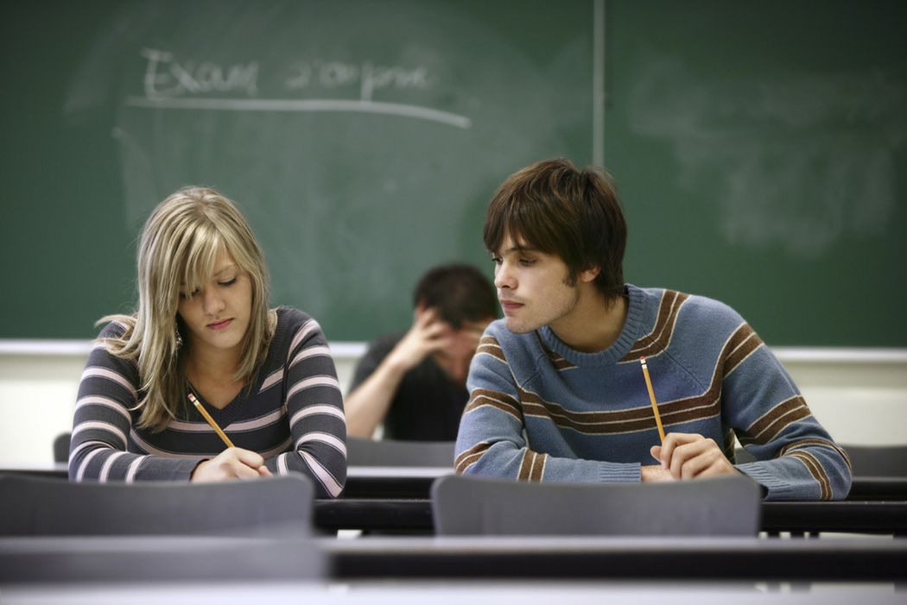
Wellbeing and Enterprise
Skills for Life include – managing time, planning and organising,
communicating, solving problems, undertaking tasks at
short notice, working with others, thinking critically and
creatively, learning and continuing to learn, taking responsibility for their own development, managing and being managed by others.
All these skills will enable young people to become – successful learners, responsible citizens, confident individuals and effective contributors i.e. the 4 capacities of Curriculum for Excellence.
We are currently in the process of discussing and implementing how to include this in our planning.

Road Safety
We are pleased to inform you that we are re-introducing the ‘Walkwise’ initiative
which introduces our Primary 3 pupils to the crossing of roads in safe places.
Despite this being organised pre-Christmas we were concerned to be informed by
a driver that one of our pupils who was going home at a lunchtime ran across the
road and nearly caused an accident!
We realise that we need to be constantly considering safety around
school and re-visiting this with our pupils. However, can we please ask that you as
parents support us by talking to your children about Road Safety. Thanks.

‘Showcase’ – please put the date in your diary, now!
During the last 2 years we have held very successful Learning Festivals during the month of February. The first festival gave you the opportunity to observe the new style of learning within school. Last year we held two festivals – Numeracy and Literacy.
When considering how to take this forward this
year we have looked at comments from yourselves,

our pupils and staff and have developed the following package –
Festival – ‘Showcase’
Learning – Co-operative Learning
Date - Thursday 31st March
Time - Hall 1.30-1.45pm
- Class 1.50-2.50pm
- Refreshments 2.50-3.20pm in the dinner area
Unfortunately we can only invite 1 adult per family due to the space available in each class area. Please look out for further information during the middle of February.

Important dates this term
As you can see another very busy term in school!
February T1st -Transition teacher, Maria Gibson continues visits to P.7 pupils
-Matthew Fitt, Scottish author to visit school
W2nd -Scottish Football training for P.4 continues
M7th -P.7 Transition-Maths/Science/H.E. programme
T8th -Dodgeball Tournament for Girls Allowed
W9th -K’Nex Challenge for P.5 & P.6 pupils in school
M14th -P.7 Transition-Maths/Science/H.E. programme
Th17th -InSet day-school closed to pupils for staff training
F18th –M21st - Mid-term holiday – school closed to pupils and staff
T22nd -P.3 tennis training begins – in school
W23rd -P.6 cricket training begins – in school
M28th -P.4 Tri-Golf Festival
March W2nd -P.7 Transition - Enterprise Day
Th3rd -P.7s to Water Rescue at Baths
M7th -P.7s to Transition – Maths Puzzle
T8th&Th10th – Parents Evenings for both nursery & school
W9th -Euro Quiz
F11th-25th -Eco Weeks
F11th -Fairtrade Football competition
T15th -P.5 Scottish Country Day of Dance
W16th -County Cross Country Championship
Th17th -Bingo Night
M21st -P.3 Tennis Festival
T22nd -Challenge Day in school
M28th -P.7 Information Literacy Transition event
Th31st -‘Showcase’
April F1st -Easter holidays begin at 3.10/3.20pm
M18th -School opens for the summer term

Future dates for your dairy
Equally we have been told by Forfar that school will be required as a Polling Station for the European Elections on Thursday 5th May which means that school will be closed to pupils only on that day but not for staff. Please note this date in your diary. Thank-you.

‘Fun In Athletics Festival’ – Angus Final
On 26th January Mrs Muir, David Muir and Mrs Mitchell took 22
children from P.6 and P.7 to Forfar to represent Borrowfield School
at the ‘Fun In Athletics’ Angus final. We left school at 9.10am and
were back at 12.30pm for lunch. Some of the events we took part in
were the obstacle race, speed bounce, chest push and over and under. It was really good fun and we ended up coming in 5th place. We trained very hard to get us ready to go to the final.
reporters – Kyle Ross and Fraser Bruce P.6/7

Transition – Information Literacy event
We went to the Academy library to find out how to use it. When we got there we were given a number and we had to find a book with that number on it. We had to rate the book and see if it was any use for our given topic. After that we went on the computer to find books in the library on our school topic and websites using a programme called ‘Search Star’. We really enjoyed it and we can’t wait until we go up and use it properly.
reporters – Codie Petrie and David Gibbs P.7
School Concert
The Christmas Concert was really good. All of the infants sang two
songs in their classes. My class sang two songs about Santa. We designed
our own hats. We made our hats with glitter. I had a good time.
reporter – Logan Stewart P.3D

P.4 Assembly
We did our own class assembly about New Year. We had people talking about fire festivals, first footing and new year. We also talked about some other things. We did some poems and here’s their names ‘Hooray, hoorah’, ‘It’s New Years Day’ and ‘New Resolutions’. We had a great time doing it. We had practised a lot.
reporter - JasminSclater P.4

Scottish Football Training

We play lots of games and Stewart is a nice friendly coach. Sometimes we
play football and he helps us to kick the ball. It is lots of fun and
everyone is enjoying it. It helps you to play football.
reporters – Grace Lamond & Jay Robertson P.4

